Why Culture?

Craig Hassel

Learning to “see” culture within ourselves can be a significant developmental task. In my own case, I saw no need to give my own culture any serious consideration for the first 35 years of my life. Growing up in a relatively affluent, suburban, almost exclusively mono-cultural Midwestern environment and becoming a professional nutrition scientist, I had no need whatsoever to concern myself with culture. If anything I identified myself as a Midwestern American. Culture was virtually invisible; concepts of time, progress, productivity, responsibility, control etc. were simply taken for granted as the way things were. Culture was hidden in what was considered “normal”.
To truly appreciate what other cultures might have to offer, we must be able to see culture in ourselves. If we do not see culture in our own thinking, actions and reactions, we will be limited in our understanding and relationship with people of other cultures. This is especially important when many aspects of culture are simply taken-for-granted as the way things are.
What is culture? Webster describes culture as “the totality of socially transmitted behavior, arts, beliefs, institutions, and all other products of human work and thought”. Culture provides the underlying assumptions of an entire way of life, allowing us to make sense of the world and our lives.

A cultural lens helps us to better recognize that making sense of our world, no matter who we are, always happens within a cultural context. The Talmud offers us the following quote: “We do not see things as they are. We see things as we are.”

A recent report from the Minnesota Department of Health points to culture as a resource:

“Minnesota’s strengths include the state’s people, communities, systems and the way these people and communities take on significant challenges. Notable among these strengths is the growing racial, ethnic and cultural diversity of the people of Minnesota, joining new energy and creativity to the wisdom of the people who have lived here for generations, generating economic opportunities and making significant contributions to all aspects of life in Minnesota”.

Our Worldview as Culture

Despite efforts to think for ourselves, our thoughts are greatly influenced by those around us. Without knowing it, we absorb ideas and beliefs from an early age; based on what others around us say or do. If we look at or observe the various aspects of our mind activity, we will discover thoughts, concepts, beliefs, story-making, preferences, tendencies, images, memories, imagination, sensations, self-images, sense of identity and various other psychological phenomena. All these dimensions are conditioned and influenced in by those around us through a process of acculturation.

This often subconscious process creates within us a set of ideas, a frame of reference that is closely aligned and coherent with the ideas shared by those around us. If these ideas are widely accepted as representing reality, they become foundational to our thinking. They represent what is “given”, an implicit frame that is simply taken for granted as true and non-negotiable. This is called a “worldview”. Most of us are not conscious of our worldview. A worldview is not consciously learned so much as implicitly absorbed from our surrounding culture. We usually think with our worldview and because of our worldview. Less often do we think about our worldview.

It is easy and natural to see our experience and thinking as representing reality. This default allows us to navigate everyday life more easily. It also can lead us to assume that others experience and think about the world pretty much as we do. This is why it feels disruptive when we encounter people with a very different view from our own experience. Encounters with cultural difference at the worldview level can evoke unsettling dissonance that challenges one’s sense of reality.

I’ll share an example from my own experience. As an Extension nutritionist working on Indian reservations in Northern Minnesota, I was introduced to ideas that spirituality and conscious intelligence are not limited to the human brain, but exist throughout the body, environment and cosmos. I encountered Anishinaabe teachings that refer to Four Orders of Life. The First Order is Omizakamigokwe (Mother Earth), followed by Gitigaanan (Plants); then Awesiinhyag (Animals) and, lastly, Anishinaabeg (Human Beings). The teachings are simple – Earth, plants, and animals can exist without human beings, but human beings cannot exist without animals, plants, or the Earth. Therefore, human beings have a duty and responsibility to protect the other three orders of life. The teachings explain humans as the most recent arrivals, the most dependent upon on all other life forms for survival and the least in tune with the rhythms of the natural world. As all else preceded humankind, we can be mentored by the world around us if we listen and observe carefully. On this basis, humans are considered in some ways the most pathetic or weakest beings in nature.

As a professionally trained scientist, I could have easily and summarily dismissed these ideas without so much as a second thought. But in giving them serious consideration and critical reflection, my commitment to integrity as a critical thinker forced me to confront my own worldview as a European American and Christian cultural construction; in this case convictions that humans are superior to or with dominion over other life forms, and ideas of the human mind as the exclusive source of consciousness and intelligence in an otherwise objective, materialistic world.

This example illustrates how many of our beliefs did not originate with us but have been transferred to us, reinforced, and approved of by those with influence over us until they are within our minds as a hidden, yet powerful foundational worldview. One reason we may fail to question our most basic assumptions and beliefs is because we tend not to recognize them as assumptions. Often, they are simply taken for granted as the "givens" of life, the way things are. A worldview is usually passed on from one generation to another with minimal change. It represents one of the deepest and most powerful aspects of culture. Our worldview is integral to our sense of identity and to how we see and understand the world.

James Sire describes a worldview as follows: “So what is a worldview? Essentially this: A worldview is a commitment, a fundamental orientation of the heart, that can be expressed as a story or in a set of presuppositions (assumptions which may be true, partially true or entirely false) that we hold (consciously or subconsciously, consistently or inconsistently) about the basic constitution of reality, and that provides the foundation on which we live and move and have our being”.

Consider these descriptions as a way to help you begin to grasp the concept:

“A worldview can be expressed as the web of presuppositions, convictions and beliefs we hold that form the basis for how we perceive and comprehend the world.”

“A set of mental categories arising from deeply lived experience which essentially determines how a person understands, feels and responds in action to what he or she perceives of the surrounding world.”

“The subjective entities which people in a given cultural context are dependent upon, subordinate to, and products of.”

“From the point of view of its adherents, a worldview is incontestable and provides the criteria for all thinking.”

Despite efforts to think for ourselves, the impact our culture has upon us is much greater than we often know or care to accept. It’s just that most of the action happens beneath our everyday awareness. Our worldview constitutes a web of hidden yet powerful underlying assumptions and values about the world. It provides reinforcement for a society’s way of life.

Our underlying worldview greatly influences our sense of identity, how we interpret life experience, our fundamental values, our outlook on life, and our point of view that we express to others. It serves as a foundation for evaluating events and circumstances, providing criteria of acceptability. As young children, we usually accept as true the views of our parents and teachers. We are encouraged and rewarded for belief and behavior that reflects the norms of our worldview.

Frequently we believe that our worldview represents reality itself, is “correct” and that others share (or should share) our worldview. Once our worldview becomes established, it provides an integrating function for new data, information, knowledge, values or experiences. But we do not automatically interpret the world realistically. Our worldview profoundly influences future thinking by acting as a filtering lens so that data, information and ideas compatible with our worldview are selectively retained over information that doesn't fit with our thinking. This helps us to maintain, strengthen and reinforce our thought processes (see ladder of inference, Figure 1).

Confirmation bias is a term used by psychologists to describe the tendency to search for, select or interpret information in a way that confirms one’s preconceptions. When we are not conscious of our preconceptions, we become blind to our biases. One tendency is to create a polarizing “we-they” dynamic among those sharing a worldview.

If we have continued success, our worldview becomes deeply reinforced and serves as a tremendous source of stability, strength, pride and self-esteem, so long as the environment is stable. Many people in the United States today share a worldview that has been greatly reinforced through continued success. Natural, undisciplined thinking can lead us to accept our worldview as either reality or correct, based upon our success. It can lead us to apply standards of judgment without ever questioning our criteria for judgment. We easily make assumptions without ever being aware that we are making them. This natural disposition to be unaware of our thinking process is uncritical thinking.

But as the environment changes, some of our entrenched worldview assumptions can become a liability precisely because of their strength and resistance to change. Periodically, our most basic worldview assumptions need to be surfaced and critically examined to determine what to hold onto and what to let go. If unexamined, they may operate to limit the alternatives for renewal and innovation. This is where a capacity for critical reflection on our ideas, our experience and our “cultural lens” can be helpful.

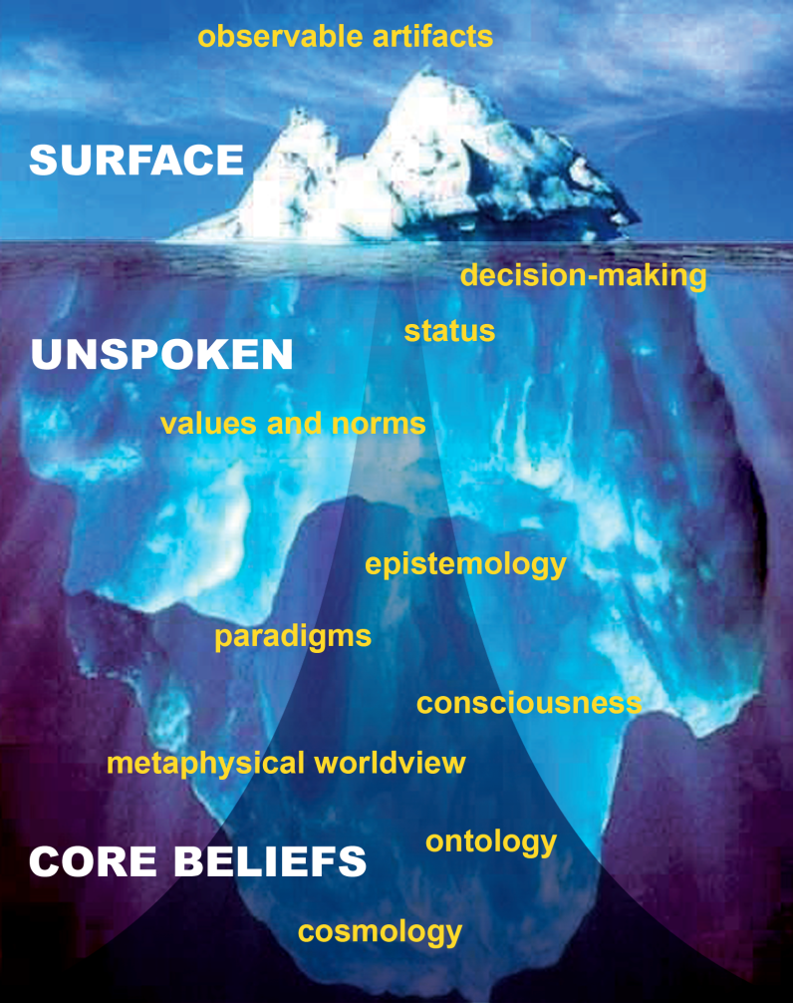

The Iceberg Metaphor of Culture
I have found it useful to consider the concept of culture using the iceberg metaphor, first seen on the internet in 1999. When we confront another culture or critically examine our own culture, we can use the iceberg metaphor to help us better recognize different levels of culture, including those dimensions that often sit beneath our conscious awareness. A version of this model is often used in Peace Corps volunteer training. The iceberg metaphor is imperfect in some ways but can be a useful tool to help us gain awareness of culture at different levels. An adaptation of the iceberg model that I use is depicted in the Figure above.

Let’s take a closer look by starting near the top of the iceberg, the part showing above the water line. This represents the empirical world of observable artifacts; those dimensions of culture that are visibly apparent to others. Here we would find personal appearance, clothing or dress, housing, literature, music, food etc. As a nutrition scientist, my interests in the empirical realm would include foods or food components, recipes, ingredients, harvesting, processing, cooking and storage methods, along with eating patterns and observable food-related behaviors. Because the artifacts of culture can be observed, measured and verified by others, they fit well with the mindset of empirically trained scientists. As an empirically-based biological science, it should come as no surprise that the vast majority of nutrition science is concerned with the artifactual dimension of human culture.
Surface artifacts are quite often manifestations of deeper dimensions of culture that are less visible but very powerful aspects of human experience. In the iceberg metaphor, these so-called “unspoken” dimensions – though not always unspoken – lie below the water surface as less tangible aspects of culture. Included here are concepts of status, decision-making and individuality, along with norms regarding values, justice, leadership, and personal relationships. Craig Storti has studied how different cultures vary along continuums with respect to concepts of self, time, locus of control, etc. Some of these cultural continua are:

Concept of Self: Individualist Collectivist
Individualist: The self is the smallest unity of survival; looking out for one’s self protects others; personal fulfillment is the greatest good; independence and self-reliance are highly valued; children are taught to stand on their own two feet; workers don’t mind individual recognition; one’s identity is personal and individual, not a function of one’s membership or role in a group.

Collectivist: The primary group, usually the family, is the smallest unity of survival; looking out for others protects one’s self; group harmony is the greatest good; children are taught to depend on others, who in turn can always depend on them; employees don’t like to stand out, they prefer group/team recognition; identity is a function of one’s membership/role in a primary group.

Universalist Particularist
Universalist: What’s right is always right; there are absolutes which apply across the board; the law is the law no matter who one is, there should be no exceptions; consistency is important; “fair” means treating everyone the same and one should try to make life fair.

Particularist: There are no absolutes; what’s right depends on the circumstances; there must always be exceptions (for ingroup members); consistency is not possible (life isn’t that neat); “fair” means treating everyone uniquely and no one expects life to be fair.

Concept of Time: Monochronic Polychronic
Monochronic: Time is a limited commodity; the needs of the people are subservient to the demands of time; deadlines and schedules are important; plans are not easily changed; people may be too busy to see you; people live by an external clock.

Polychronic: Time is bent to meet the needs of people; there is always more time; schedules and deadlines are easily changed; plans are fluid; people always have time to see you; people live by an internal clock.

Locus of Control: Internal External
Internal locus of control: Fate has little or no importance; there are few givens in life, few things that can’t be changed and must just be accepted; where there’s a will there’s a way; one makes one’s own luck; unhappiness is one’s own fault; people tend to be optimistic; life is what you make it.

External locus of control: Fate plays a major role; people believe they have limited control over their destiny/external events; many things in life must be accepted/can’t be changed; success/lack of success is partly a result of good/bad fortune; people tend to be realistic/fatalistic; life is what happens to you.

Storti discovered that people from the U.S. were generally on the far left side of the continua (the first category in each continuum) and people from Asia, Africa, and the Middle East were generally on the right side. Certainly Storti’s categorizations contain some problematic generalizations and stereotyping. They are not intended to reflect individual variability that certainly exists within each nation/continent, but they are useful in a broader sense. What are the implications of the U.S. being on the far side of each continua?

An important concept of the iceberg is that of “cultural rootedness”; the governing power of deeper dimensions over observable artifacts that lie above. Culture brings with it fundamental differences in how we see and think. It is not uncommon for even well-educated individuals who exhibit extensive knowledge of customs or language artifacts to presume cultural similarity or universality with regard to less visible or less conscious dimensions of culture, such as the dimensions described above. The result is imposing one’s own familiar frame of reference as an assumed universal truth. Again, this represents an understandable yet uncritical stance. But by bringing critical reflection to one’s own culture, one can recognize its constructed and contextual nature. Recognizing this creates an openness that allows for consideration of other cultures that may initially seem unexplainable or problematic. Thinking critically about one’s cultural grounding creates opportunity for sharing and learning with other cultural orientations.

This observation above brings us to another important aspect of the iceberg metaphor. Most of the iceberg mass lies beneath the surface, suggesting that the majority of cultural difference lies with the less visible, more subjective dimensions of culture. Two implications are worth mention. First, the model metaphorically suggests that what we see is only the tip of the iceberg. Second, as every human society has had to develop its own knowledge as a matter of survival, the greatest scope and power of cultural diversity might lie with the deeper, more subjective, unseen dimensions. People who impose aspects of their culture as universal truth without giving appropriate consideration for cultural diversity risk excluding or discounting most of the richness and power of cultural diversity, as well as to diminish those who hold such knowledge.

Ways of knowing, including paradigms of western science are culturally rooted in the still deeper realm of metaphysical worldview. The core beliefs of a metaphysical worldview are represented as the deepest region of the iceberg. We usually think with our worldview and because of our worldview, not about our worldview. The iceberg metaphor attempts to communicate the richness and vastness of the unseen dimensions of cultural diversity that lie beneath physically observable features. As the opening example illustrates, encounters with cultural diversity at the worldview level can evoke unsettling dissonance that challenges one’s sense of reality. Patience and courage in holding such dissonance can reveal unconsciously held dimensions of human subjectivity. Vine Deloria Jr. puts it this way:

“The major difference between American Indian views of the physical world and Western science lies in the premise accepted by Indians and rejected by scientists; the world in which we live is alive. Many scientists believe this idea to be primitive superstition and consequently the scientific explanation rejects any nuance of interpretation which would credit the existence of activities as having partial intelligence or sentience. American Indians look at events to determine the spiritual activity supporting or undergirding them. Science insists, albeit at a great price in understanding, that the observer be as detached as possible from the event he or she is observing. Indians know that human beings must participate in events, not isolate themselves from occurrences in the physical world. Indians thus obtain information from birds, animals, rivers and mountains which is inaccessible to modern science. ”

Thought As a Cultural Construction

If all thought begins somewhere, that somewhere can be understood as a worldview. The examples above illustrate how worldviews can differ significantly from one cultural context to another. If this is true, we should expect that styles of thought should differ as well. The work of Richard Nisbett et al., a Cognitive Psychologist and member of the National Academy of Sciences has demonstrated experimentally that social constructs are at the very foundations of cognitive processes one uses to perceive experience and make sense of situations. Human perception and thought processes were presumed by many professionals to be universal until his work demonstrated that cultural orientation significantly influences how experience is perceived and how people think. Significant cultural differences exist among cognitive processes and how we know. Given that producing knowledge about the world is a natural human activity, such findings should not be surprising.

An important dimension of cultural awareness is using critical self-reflection to better understand the culture we bring with us into our intercultural interactions. This includes our approaches for creating knowledge and generating understandings of the world. One of the goals of Healing Roots is to create healthier intercultural interactions. To do this, we need to better understand ourselves by surfacing our implicit assumptions as explicit ideas and giving them over to fair-minded reflection. It is difficult work that requires courage and integrity, but can yield greater understanding of ourselves and a more empathetic interactions with others.

Additional Reading
Cajete G. (2000) Native Science. Natural Laws of Interdependence. Clear Light, Santa Fe, NM.
Deloria Jr V. Red earth white lies. Golden, Co: Fulcrum; 1997, p40.
Hassel, C. (2005) The craft of cross-cultural engagement. Journal of Extension 43:6 #1. http://www.joe.org/joe/2005dec/a1.shtml.

Nisbett RE, Peng K, Choi I, Norenzayan A. (2001) Culture and systems of thought: Holistic versus analytic cognition. Psychological Review 108(2):291-310.

Nisbett RE. (2003) The geography of thought. How Asians and Westerners think differently…and why. The Free Press, New York, NY.
Popper, K. (1959) The Logic of Scientific Discovery. Basic Books, New York.

Powderhorn/Phillips Cultural Wellness Center. (2002) Healing From the Four Directions. Proceedings from: Cultural Wisdom for Group and Community Healing.
Sire, J. (2004) Naming the Elephant: Worldview as a Concept. Intervarsity, Downers Grove, IL.

Tarnas, R. (1991) The Passion of the Western Mind. Ballentine, New York, NY pp343-44.

Tuhiwai-Smith L. (1999) Decolonizing Methodologies: Research and Indigenous Peoples. University of Otago Press, Dunedin, New Zealand.

Wallace, B.A. (2000). The taboo of subjectivity. Toward a new science of consciousness. Oxford University Press, New York, pp17-39, 2000.

Craig is an Associate Professor & Extension Specialist, Food & Nutrition with the University of Minnesota. He has studied culture with Healing Roots for 12 years
Webster’s II New College Dictionary. New York: Houghton Mifflin; 1999, p.274.
Advancing Health Equity in Minnesota: Report to the Legislature. Minnesota Dept Health. Feb 2014, p.18
This teaching was shared with me by Paul Schultz “Wimbaa Ogaan” a traditional healer and spiritual leader at White Earth, who passed on in 2011.
Sire, J. (2004) Naming the Elephant: Worldview as a Concept. Intervarsity, Downers Grove, IL.
Deloria Jr V. Red earth white lies. Golden, Co: Fulcrum; 1997, p.40

